**Strategic Plan 2024-2028**

***Mission:***

***The Haymarket Regional Food Pantry (HRFP) is a community-based organization composed entirely of volunteers. We are dedicated to eliminating hunger by providing food to those in need of assistance in Haymarket, Gainesville, and surrounding areas.***

***We will orchestrate five interconnected strategies to achieve the HRFP’s mission, vision, and financial sustainability.***

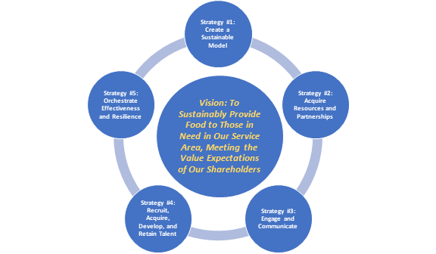

***We Value:***

***\*Respect, Compassion and Honesty *Nutrition Education & Advocacy *Wise Use of Resources***

***\*The Diverse Talents of Staff and Volunteers *Active Listening and Learning***

***\*Leadership Excellence * Creativity, the Pursuit of Knowledge, and Sharing of Expertise***

***to Result in Social Justice***

***We Provide Value to Our Stakeholders:***

***\*Clients * Volunteers *Food Donors/Sources *Financial Donors * Community Collaborators***

***\* Partner Agencies***

**Strategic Plan 2024-2028**

**Getting Started: The State of HRFP As We Begin 2024**

At its inaugural Strategic Planning meeting on January 24, 2024, the HRFP Planning Team began by assessing the state of food insecurity in Prince William County, the dramatic growth in clients in the past 24 months and the associated demographics of the base. ***The analysis and discussion concluded that the paramount issue facing the HRFP was sustainability:***

* In a recent Capital Area Food Bank Survey, the prevalence of food insecurity in Prince William County was reported as 36% of the population.

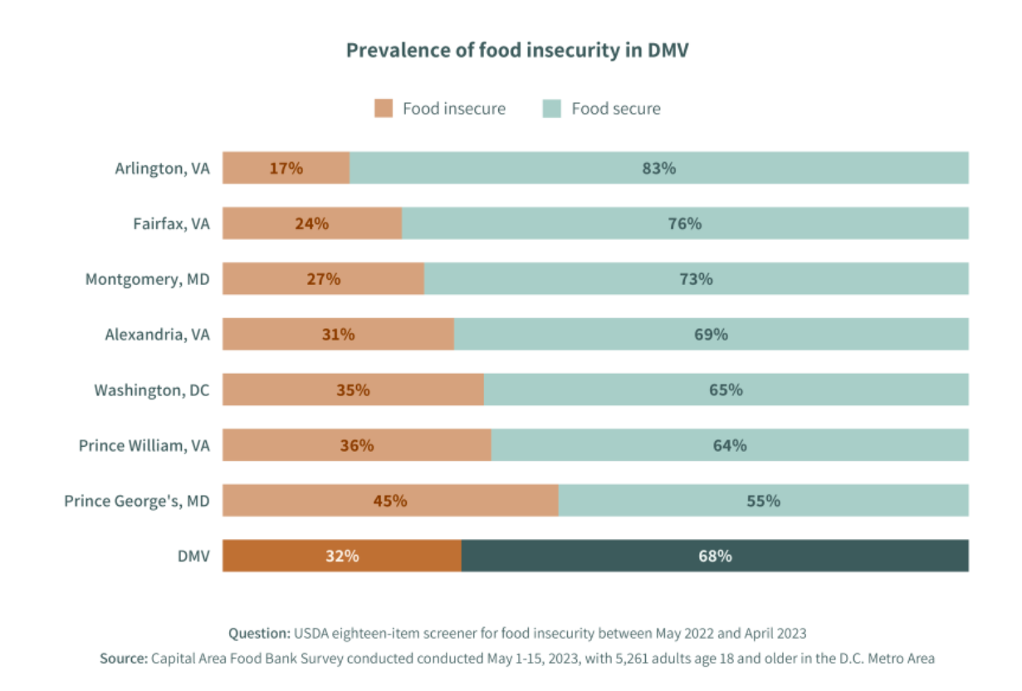

* HRFP growth statistics:
  + In 2023, the number of clients served by HRFP grew by 61.3% to 59,768 persons. As recently as 2020 the HRFP had served 30,000 clients.
  + This growth severely tested the capacity of the HRFP to deliver services, undermined volunteer morale, and stressed relations with key stakeholders.
  + Much of the growth in clients has occurred from outside our traditional core service area – by 2023 41.04% of our clientele was from Gainesville, Haymarket, or Bristow.
* Data from the Capital Area Food Bank indicate that clientele from Manassas and Manassas Park (currently 48% of HRFP food recipients) have access to 11 food sources closer to home. The remaining 11% of clients reside in Fauquier and Loudoun Counties also with associated food sources in closer proximity.
* Data from the Prince William County Planning Commission cites a 5% increase in population in the Gainesville/Haymarket/Bristow area annually over the next 5 years.

After carefully considering four options for creating a sustainable service area, the Strategic Planning Team reached consensus and recommended that we move toward focusing only on Prince William County, minus Manassas and Manassas Park. The goal is that the HRFP will serve between 30,000-35,000 clients in 2024, providing the ability to help neighbors closer to our location as well as providing for future growth.

The HRFP Board will carefully execute on this decision using data from the Capital Area Food Bank and careful consultation with our stakeholders. We will create associated action plans to address the five interconnected strategies.

**Five Strategies to Achieve our Mission, Vision, and Sustainability**

The figure below portrays the five interconnected strategies the HRFP will pursue.



**Strategy 1. Create a Sustainable Model**

Achieving sustainability requires efforts that cut across all the strategies:

* Create a sustainable model based on a feasible core service area and refine the model as conditions change.
* Acquire/maintain resources and partnerships. Communicate and engage stakeholders – clients, volunteers, food sources/donors, financial donors, community collaborators, and partner agencies.
* Acquire, train, and develop talent – volunteers, clients, other stakeholders.
* Orchestrate resources, partnerships, engagement, and talent to achieve operational effectiveness, excellence, and resilience.
* Focus on providing value to our stakeholders – create positive experiences that meet their value expectations and build their ownership and commitment to our mission.

The HRFP should be constantly questioning the services we deliver, how we are using our resources and partners and how we can consistently perform better. We strive to understand what our clients and other stakeholders need through annual surveys, focus groups, and active

engagement. The table below identifies areas for improvement meeting stakeholder expectations.

**Achieving Sustainability by Exceeding Stakeholder Expectations**

|  |  |
| --- | --- |
| Stakeholders | Actions |
| Clients | * If we have food, they will come. * Provide a consistent high level of service. * Provide a consistent number of products that clients have requested. * Constantly and consistently communicate policies and procedures. |
| Volunteers | * Attract and nurture a diverse group of volunteers. * Assure that they are reliable. * Communicate and engage, make them deeply invested. * Celebrate volunteers with frequency. |
| Partners | * Research and attract excellent partners. * Provide consistent acknowledgement of their participation. * Invite partners to visit and participate. * Communicate and engage, demonstrating the value they receive. |
| Food Donors and Other Sources | * Be proactive – reach out to companies and community groups regarding food drives. * Create consistent donations - (ex: suggest that the Girl Scouts do their drive in March). * Create a calendar of food drives. * Communicate and engage, make them deeply invested. |
| Financial Donors | * Be programmatic – focus on the value from their donations. * Build structure – be intentional. * Be transparent, we are going to be around for a long time. * Relationship management, designate someone to build those relationships. * Provide recognition to constituencies. * Frequent, focused, and targeted communications. * Communicate and engage, make them deeply invested. |
| Community Collaborators | * Community serving community. * Actively engage our community collaborators and involve them in the service we provide. Build their ownership and commitment. * Communicate and engage, make them deeply invested. |
| Partner  Agencies | * Manage relationships on both sides (particularly Capital Area Food Bank) * Ask for discounts from food suppliers and inform suppliers of our needs. * Communicate and engage, make them deeply invested. |

The action plan for Strategy #1 will address the following issues:

* Need for surveys, focus groups, and feedback on client needs and food pantry performance. Also build the capacity to mine and analyze data.
* Need key performance indicators/metrics and targets for the 2024–2029-time frame – basic elements of sustainable service area, client needs, food pantry performance.
* Update documents and policies.
* Readdress by-laws.
* Readdress board of directors - size, representation, succession plans.

**Strategy 2: Acquire Resources and Partnerships**

The action plan for Strategy #2 will address the following issues:

|  |  |
| --- | --- |
| Resources | Actions to Acquire Resources |
| Funds | * We need to increase food and financial donors. * Constant communication to give donors ownership. * Need an individual to lead fundraising efforts. * Donors need to be pushed to make regular donations. |
| Data | * There is always room to get more and better data. * Issues around data include:   + What are we doing with it?   + What do we want to be doing with it?   + How can we make it more accessible?   + How can we use it to make better decisions and build support? |
| Staff/volunteers | * An effort is underway to move volunteer information to Salesforce. * Need an organizational chart and/or responsibility matrix. * Need to improve training and communication with volunteers. |
| Budgeting | * Create an Annual Budget. |
| Programming | * Basic Programs: Food distribution * Expanded programs: Holiday meals, birthday bags. * Referral programs: Cake4kids   + What is a program? Anything repeatable and continuing.   + What is a project? A one-off situation – signing clients up for insurance, traveling immunizations. |

The HRFP has partners for food purchasing, food drives, donations, government interactions and schools.

**Current HRFP Partnerships**

|  |  |
| --- | --- |
| Partnerships | Description |
| Volunteers | * Sources of Volunteers - Website, Facebook, Corporations, Area Schools, Church Groups, Community Groups (scouts, sports teams) * Work Performed - Administration; Food Sourcing, Maintenance, Distribution; Board Service; Leadership. |
| Food Sources | * Food Donors - Wegmans, Giant, Giant Warehouse, Walmart, Harris Teeter(2), Aldi, Sprout, Safeway, BJs * Farms - Fauquier Farm, Oak Spring Garden Foundation * Food Drives - 23 drives in 2022, primarily scouting organizations, sports teams |
| Financial Donors | * Types of Donations - Corporate or Individuals, recurring or sporadic * Forms of Donations - Grants, Gifts, In Memory |
| Community Collaborators | * Churches - St. Paul’s, St. Katherine Drexel, Park Valley, Gainesville United Methodist, Haymarket Baptist, Holy Trinity, Shepherd of the Hills Lutheran, Grace, Love, St. Michael’s, Manassas Presbyterian, Sudley Methodist, * Legislators – Brentsville District Supervisor, Gainesville District Supervisor * Community Organizations – Heritage Hunt Giving Circle, Dominion Valley, Regency Women’s Club, Boy Scouts |
| Partner Agencies | * Capital Area Food Bank * Cakes4Kids * Schools – Gainesville High School, Patriot High School |

The Action Plan for Strategy #2 will address the following issues:

* Plan for financial donors - consistency is key – need more financial donors to achieve sustainability.
* Plan for food sources/donors – consistency is key.
* Provide leadership for fundraising.

Need key performance indicators/metrics and targets for the 2024–2029-time frame – numbers and composition of food, funds, data, staff, volunteers, and programs.

Lynn and Mark agree to take on food drives and donors.

**Strategy 3: Communicate and Engage**

The principles for communicating with and engaging stakeholders are:

* Target communication and engagement to the needs of different stakeholder audiences.
* Meet people where they are. (We do this well with our clients, but not as well with other stakeholders.)

|  |  |
| --- | --- |
| Partner | Actions to Communicate/Engage |
| Clients | * Engage clients personally through respectful phone interactions as well as food distribution. * Provide convenient, effective communication channels for existing and prospective clients and communicate policies and procedures to internal stakeholders. |
| Volunteers | * All volunteers should know the basics (pillars) of the organization. * All volunteers should use the same talking points and make them their own. * Use volunteers to help create the list of basics stemming from the HRFP values denoted above. |
| Food Donors | * Constant communication and engagement to demonstrate the value their food donations provide the clients. |
| Financial Donors | * Constant communication and engagement to give donors ownership and to demonstrate the value of their financial contributions. |
| Community Collaborators | * Engage community collaborators to understand the value of the HRFP to the community and their organization. |
| Partner Agencies | * Engage partner agencies in problem solving, information sharing and joint ventures. Establish effective two-way channels of communication. |

The Action Plan for Strategy #3 will address the following issues:

* Formulate a focus group to create an HRFP Basics Card that will get volunteers on the same page (Charlie and Eileen).
  + Mix morning, afternoon, and evening volunteers, and achieve buy-in
* Kim to analyze newsletter data – who opens? When is it opened most frequently? When do donations correlate to the publishing schedule?
* Need key performance indicators/metrics and targets for the 2024–2029-time frame for communication and engagement.

**Strategy 4: Recruit, Acquire, Train, and Develop Talent**

Training must be enhanced both for big picture issues and specific training needs.

|  |  |
| --- | --- |
| **Big Picture Training and Talent Development Needs** | **Specific Training Needs** |
| * Recruitment and onboarding of volunteers and leaders. * Training and succession planning for leadership roles. * Board training. * Mini videos to onboard new volunteers - from specifics for jobs but also for generic things like who we are and what we do. * Training for managing volunteers. * Continuing talent development of volunteers. | * Food handling * Donation receiving * Check-in and check-out * Client paperwork * Voicemail * Computer training * Responsibilities of each station |

The Action Plan for Strategy #4 will address the following items:

* Need key performance indicators/metrics and targets for the 2024–2029-time frame for training and development.
* We see the need for an NDA or confidentiality statement for volunteers who access personal (PII) information. Amy to send examples.
* Charlie and Eileen to review the on-boarding video used by Laura Smith.
* Eileen to follow up with the non-profit coaching organization – A meeting set for 1/30 at noon.
* Establish actions for specific training needs along with deadlines.
* Consider rewriting job descriptions considering responsibility mapping.

**Strategy 5: Achieve Organizational Effectiveness and Resilience**

Organization effectiveness (operational excellence) and resilience are built by using the sustainable model for HRFP as a vision guide to orchestrate programs, partnerships, communication/engagement, and talent development in ways that will fulfill the HRFP’s mission of service and establish excellent standards of performance.

The Action Plan for Strategy #5 will contain the following items:

* Need key performance indicators/metrics and targets for the 2024–2029-time frame for operational excellence.
  + The metrics in Strategies 1-4 address the number of key resources, partnerships, and activities: clients, volunteers, programs, donors, community collaborators, partner agencies, communication/engagement, and talent development.
  + The metrics for Strategy #5 address the standards of excellent practice, such as average time to fulfill a client’s order, wait time, volunteer satisfaction, etc. Developing these standards of performance, communicating them, and measuring them will be a key element of this Strategic Plan and the supporting action plans.
* Establish policies and procedures for responding with resilience to unexpected circumstances and changes in HRFP’s environment. Resilience is the ability of the HRFP to respond to emergency needs, some of which are foreseeable, and some of which are unknown. For example, in 2018 the HRFP stood up a grocery store in six days to alleviate burdens on federal employees during a government shutdown.
* A key element of operational excellence is data on the satisfaction of clients, volunteers, and other stakeholders. Laura has “satisfaction” statistics from volunteers. How can we mine this data and more?
* Other key issues:   
  + We need to grow our donor base; we can’t rely on donations to continue.
  + How long do volunteers stay with us? How long is it between signing up and starting work? Do we need to identify and onboard volunteers quicker?
  + For clients, how much time from signing up to getting service?
  + Create a dashboard for volunteer statistics and client statistics mentioned above.

**The HRFP Ecosystem Model**

The HRFP and associated constituents should understand and be able to articulate the ecosystem and the value exchanges between the HRFP and its stakeholders. Each arrow between a stakeholder and HRFP has a two-way exchange of value - one for HRFP and the second for the stakeholder. Fulfilling our promise of food for our neighbors is critical to our success.

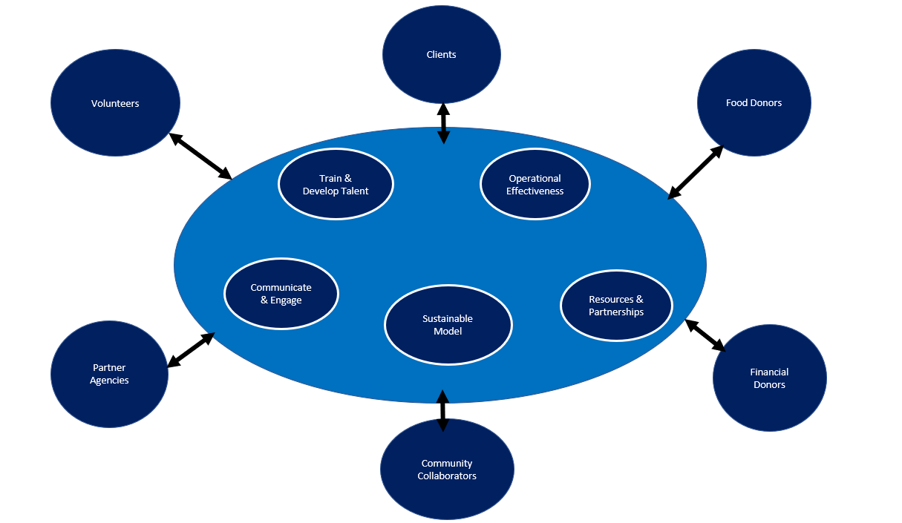

**Value Exchanges Between the HRFP and Partners**

|  |  |
| --- | --- |
| **Value Received by HRFP** | **Value Received by Partners** |
| **Satisfied Clients whose needs are met in a respectful manner are the HRFP’s reason for being**. Successfully reducing food insecurity justifies the investments made by volunteers, food sources/donors, financial donors, community collaborators, and partner agencies. | **Clients realize value through the assistance they receive in navigating HRFP’s system and receiving food assistance.** Overcoming food insecurity enables them to be better neighbors who appreciate the support of their community. |
| **Volunteers make HRFP operations possible**. They are the fuel that powers the operation and the light that makes clients feel welcome and cared for. | **Volunteers receive the personal satisfaction and gratification of doing good works for members of their community.** This value is enhanced when the volunteer experience is positive, and the food pantry operation is well managed and highly supportive. |
| **Food Sources and Donors give the HRFP a dependable, sustainable flow of food resources.** These are necessary to meet the food insecurity needs of our community and to respond with resilience to extraordinary needs that arise. | **Food Sources/Donors make HRFP’s food pipeline possible and derive a range of value propositions.** Corporate food donors benefit from giving back to their communities and provide their employees a sense of pride. The individuals involved in store sourcing, farm sourcing and food drives derive personal satisfaction from their efforts. |
| **Corporate and individual donors provide HRFP with a large portion of the financing necessary to sustain our operations.** HRFP continues to earn their trust by delivering on our promise to reduce food insecurity in our community. | **Financial Donors range from corporate donors to foundation granters to individuals.** Their value propositions range widely. But all are satisfied in different ways if HRFP delivers on its promise of reducing food security and providing a dependable, sustainable, respectful path to relieving food insecurity. |
| **Our Community Collaborators provide immense value to HRFP by providing legitimacy and access to volunteers, donors, and political support.** They serve as a megaphone to the community and provide a multi-purpose network for communication and engagement. | **Community Collaborators derive value from reducing food insecurity, which strengthens the community in which they live**. By drawing volunteers from their memberships, they provide individuals with the invaluable experience of helping others and making a difference. |
| **HRFP services great value from joint problem solving with partner agencies.** The Capital Area Food Bank helps HRFP receive discounts from food suppliers and informs suppliers of our needs. | **Partner Agencies benefit from joint problem solving with HRFP and helping us to be more effective in serving our region.** This advances the cause of partner agencies like the Capital Area Food Pantry. |

**Ideas on Metrics/KPIs and Measures of Operational Excellence/Resilience**

The teams for each strategy will develop metrics/KPIs for their strategy, extending and refining the suggestions below.

**Strategy #1 Sustainable Model** **Team Leader - Eileen Smith, Team Members TBD**

* Core Service Area - Prince William County, minus Manassas and Manassas Park ( provide zip codes)

# # Clients Served - aim for 30,000-35,000 in 2024, scale up by 5,000 more by the end of 2028

* Amount/Variety of Food Needed to Serve Client Target
* Financial Targets
  + Annual Revenues, Annual Expenditures, Net Income
  + Current Checking/Savings

**Strategy #2 Programs and Partnerships** **Team Leader - Patty Kuntz, Team Members TBD**

* # and Nature of Programs - Volume/Value of Food
* # and Nature of Partnerships - Level of Participation, By Partner
* Fundraising - Targets and Actuals
* Prospective Sources of Food/Revenues

**Strategy #3 Communicate and Engage Team Leader - Eileen Smith, Team Members TBD**

* Communication/Engagement Vehicles by Partner Category
* Nature/Level of Engagement by Partner Category

**Strategy #4 Talent Development** **Team Leader - Aimee Lowry, Team Members TBD**

* Recruitment and Onboarding Needed to Maintain Volunteer Base
* Talent Development Needed to Improve Volunteer and Leader Base
* Talent Development Needed to Enhance Partner Performance

**Strategy #5 Operational Excellence and Resilience Team Leader - Lynn Williams, Team Members TBD**

* What Constitutes Operational Excellence and Standards?
  + Satisfaction with Services and the Food Service Experience - Client Surveys
  + Satisfaction of Volunteers and Other Partners with their Experience - Surveys
  + Standards of Excellent Practice
    - Selection of Food Available, Consistently
    - Efficiency of Distribution, Waiting Times, Consistency of the Experience
    - Satisfaction of Partners, Reflected in Satisfaction and Retention
* What Constitutes Resiliency?
  + Ability to Anticipate and Stand-Up Services in Face of Government Shutdowns, the Next Pandemic, the Next Recession or Economic Turndown.
  + Continuing adaptation to changes in food suppliers/donors and client needs